Regional Event
Creation Guide

Contents

Event Setup  Event Settings …………………………………………………………………………………………………………. | P 4
Extra Event Information ………………………………………………………………………………………….. | P 8
Competitions ………………………………………………………………………………………………………….. | P 9
Competition Setup ………………………………………………………………………………………………….. | P 11
Competition Official Levels ……………………………………………………………………………………… | P 12
Music Requirements ………………………………………………………………………………………………. | P 13
Membership Requirements ……………………………………………………………………………………. | P 14
Coach & Judge Qualifications …………………………………………………………………………………. | P 18
Uploading Documents ……………………………………………………………………………………………. | P 20
Check Setup ……………………………………………………………………………………………………………. | P 21
New Event from Template ………………………………………………………………………………………. | P 22
Event Entries  Entries …………………………………………………………………………………………………………………….. | P 22
Override Options…………………………………………………………………………………………….. | P 24
Adding an Extra Charge ………………………………………………………………………………….. | P 25
Creating an Extra Entry …………………………………………………………………………………… | P 26
Reports  Entry Report ……………………………………………………………………………………………………………. | P 27
Payment Report ……………………………………………………………………………………………………… | P 29
Music Report ………………………………………………………………………………………………………….. | P 28
Music Download  How to Download Music …………………………………………………………………………………………. | P 28

Regional Event Set-Up

This guide will have all the information in so that you are able to set up your events with no troubles. However, if you do have any queries, please do not hesitate to contact Hannah on 0345 129 7129.

When a club is making an entry, the system will check that DBS and Safeguarding are in date at the time of event. But for membership, the system can only check that it is the correct type at the time of entry, not at the time of event. We would suggest that closer to the event to run a report, so you are able to see if anyone has membership outstanding.

Throughout this whole process, you can save your changes and come back to the set up at a later time, it hasn’t got to be completed all in one go.

Once logged in to GymNet via your own membership number and password, you will need to go to ‘My Account’ and select ‘My Regional Events’

This is the first screen you see. For the first time set up use New Event, if you are copying an event from previous years use New Event from Template
Make sure you either chose New Event from Template or New Event – NEVER overtype an existing competition.

You can copy from a template, the information for this is on P. 20
This section is all about adding on new events and being able to copy and event from a template that already exists in the region.

Clicking ‘New Event’ on the Home page will bring you to this page.

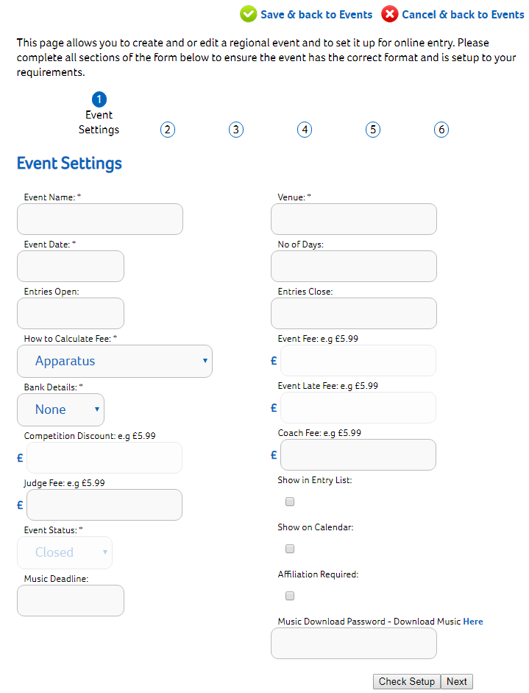
Through the set up you will have the two options of ‘Cancel & back to Events’ or ‘Save and back to Events’. If you click ‘Cancel and Back to Events’ changes will not be saved, you will need to select ‘Save & Back to Events’.

Once the mandatory fields have been completed, click ‘Next’. You are able to come back and update these details at a later time.
All changes will be saved by selecting ‘Next’.
At the top of the page you have a save and cancel option to take you back to the Events home page.

Please see below for a breakdown of what sort of information is required within each box.

REMEMBER – not all these boxes are mandatory!
Below you can see a quick description of what details need to be entered into the system and what each field means. Once you leave this page, you are able to come back to make any changes if needed. For example, if you keep the ‘Show in Entry List’ box un-ticked, once the setup is complete, you are able to come back and tick the box so that it will show on the BG website.

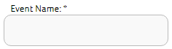 | This will be how the name is displayed on the website and entry list. The ‘Event Name’ is the title of the overall occasion. For example, 2019 West Midlands Women’s Artistic Club and Regional Grades.
 | The venue name and address will be displayed on the website and entry list. If you start typing and your venue is not there as an option, please call Hannah on 0345 129 7129.
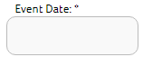 | This is the starting date of the event only. The Event Date will be used to display the event on the website calendar. Age of entrants is calculated on this date.
 | How many days does the event run for? E.G. 2days. This box can be left blank but if your event is 2 or more days, then it is better to have this box completed so that people are aware. This will be shown on the website calendar for this event.
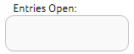 | What date is the competition open for entries? The date format must be DD/MM/YYYY. Providing that the ‘Event Status’ is set to open, as soon as this date is reached, entries will be allowed to be made.
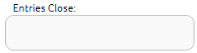  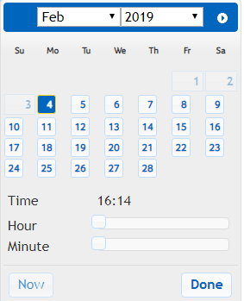 | What date does the competition close for entries? Once this date is reached, the system will automatically close the event for you. You are not required to go in and close the competition yourself.  This box also has a slider for you to choose what time the event closes. You need click on the white squares and move them across to the correct hours and minutes for the event closing time. Once this is correct, click done.
 | - This needs to be set as Competition per Entrant otherwise the fee is unable to be calculated.
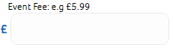 | This fee will be charged when fees are calculated by ‘Event All’ or ‘Event Per Entrant’ as selected above.
 | This is the drop-down option box, you will need to select which bank account your fees will need to be paid too. If you can’t see your nominated bank details, please contact Hannah.
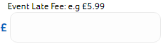 | If you are happy to accept a late entry for your event, this will be the fee that is charged if you have selected the fees to be paid by ‘Event All’ or ‘Event Per Entrant’.
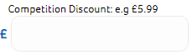 | If specified this amount is taken from the total for each subsequent competition entered.
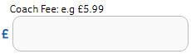 | This fee will be charged for every coach entered. It can be left blank.
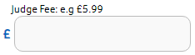 | This fee will be charged for every judge entered. It can be left blank.
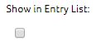 | This box must be ticked to allow the event to be visible on the entry list within GymNet.
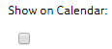 | This box must be ticked to allow the event to be visible within the British Gymnastics / Regional web calendars
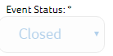 | The ‘Event Status’ overrides the ‘Entries Open’ date. You can keep the Event Status as ‘Closed’ until you have completed the set-up. If you keep the event as open, the system will automatically open for entries on the date set above.
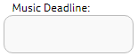 | Closing date for music uploads which can be after the main competition closing date. Clubs will still be allowed to upload music after the event closing date providing that they have completed their entry.
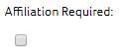 | The affiliation required box is to be ticked if the event is only open to clubs who are registered to the region.  Anyone who isn’t affiliated to the region won’t be able to enter.
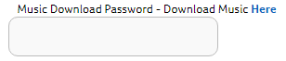 | This is the password that the sound person will need to download the gymnast’s music for this event.

*These are Mandatory fields.

Here is an example of what the page will look like once it has been completed.

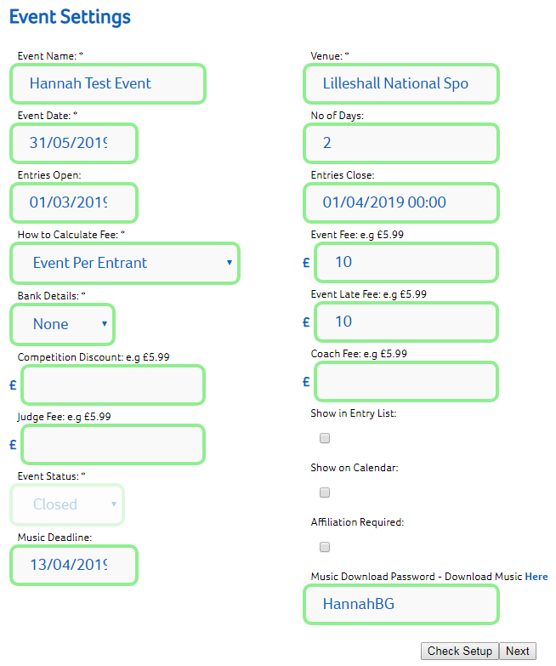

The ‘Check Setup’ option will show on the bottom of every page. This will show you if there are any errors before finalising any event and also if there is anything issues that potentially may cause an issue.

The ‘Event Status’ is closed at the moment as the event set-up has not been completed. The event status overrides the ‘Entries Open’. This has also been hidden from the Entry list and Calendar, again, because the set-up has not been completed.

When you click next, you will be taken to the Extra Event Information.

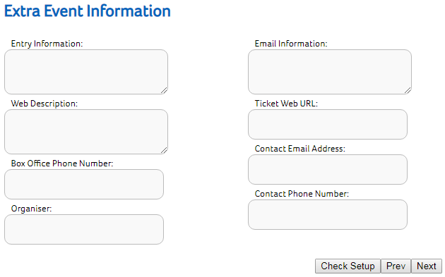
In the table below, you will be able to see what sort of information is required within each box. Not all boxes are mandatory and can be left blank.

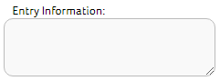 | The Entry Information is additional text that will be displayed on the main entry screen in GymNet for the club to see.
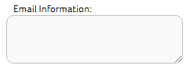 | An automated confirmation email will be sent out when an entry has been made. The information entered in here, will be included in the confirmation email.
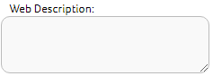 | This text will appear on the web calendar (if selected) within the ‘further event information’ field.
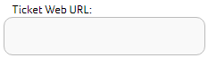 | If tickets are being sold through a 3rd party, you can add the web address and can be taken straight to the ticket link.
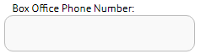 | The contact number for ticket sellers.
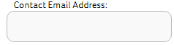 | This is the email address that the organiser can be contacted on.
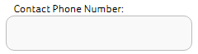 | This is the number of the event organiser. If you do not wish to be contacted by phone, please insert ‘Email Only’.
 | The name of the competition organiser.

If you click next you will be taken to this screen to add the competitions within your event.

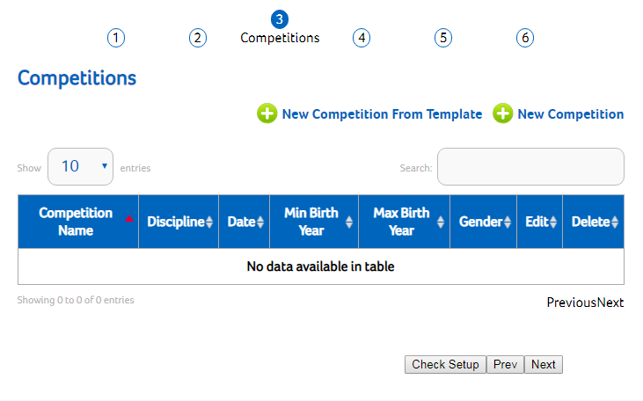
As well as moving onto the next page once the competitions have been added.
To add a new competition, click ‘New Competition’
Again, you can go to the previous page.

When you click ‘New Competition’ this is the page you will be taken too. On the next page, there is a breakdown of what sort of information is needed within the different boxes.
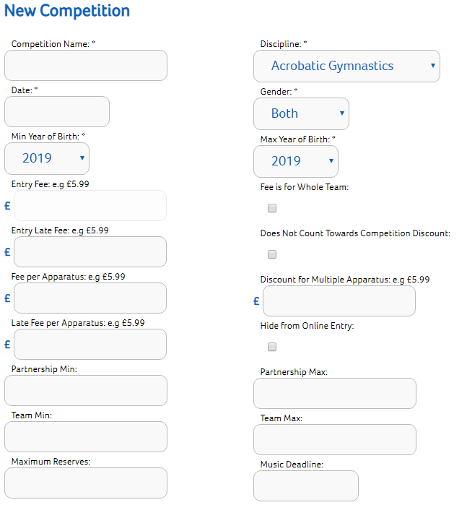
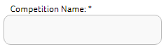 | This is the name of the competition category itself. For example, in Acro, Men’s Balance Pair 13-16
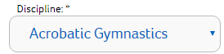 | Select the discipline that is relevant to this competition. This will enable the system to filter through the web calendar.
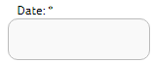 | This is the date of the competition itself. The date will also be used for age calculations.
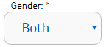 | Select the gender that is able to enter into this competition. This will stop the wrong gender being entered into the competition.
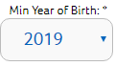 | Used to filter entries. This will also stop anyone too young from entering the competition.
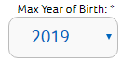 | Used to filter entries. This will also stop anyone too old from entering the competition.
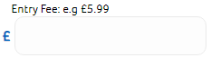 | This is the fee applied when using the ‘Competition All’ or ‘Competition Per Entrant’ charging model.
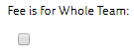 | Tick this box if the fee is for the whole team. If the competition fee is calculated any other way, please do not tick this box.
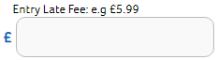 | This entry charge will be used once the closing date has passed and an override has been applied. This late charge is used when the entry fee is charged by ‘Competition All’ or ‘Competition Per Entrant’.
 | If you set up a Competition Discount on the Event Summary Screen (P. 2), then selecting this button will remove this competition from being eligible for the discount.
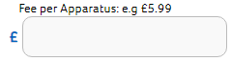 | This is the fee that is applied when using the ‘Apparatus’ charging model.
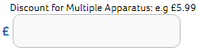 | This amount is taken from the total for each subsequent apparatus entered
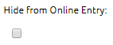 | If you tick this box, then this competition will not show in the entry list. An example of when this could be used is if the event is still open but this competition itself has reached its maximum participants.
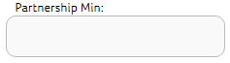 | What is the minimum number of gymnasts needed to enter for partnership? If partnerships do not relate to this competition, then please leave blank.
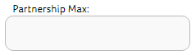 | Activates the partnership Grouping facility if this is set to greater than 1. What is the maximum number of gymnasts needed to enter for partnership? This should be used where multiple gymnasts compete together to receive a single score, such as ACRO Trios, Groups, TRA synchro etc.
 | This is the minimum number of gymnasts that are permitted into one team to enter into this competition. If the competition you are entering is an individual competition, leave this box blank.
 | Activates the team grouping facility if this is set to greater than 1. This is the maximum number of gymnasts that are permitted into one team to enter into this competition. If the competition you are entering is an individual competition, leave this box blank. This should be used for Team competitions where multiple gymnasts compete separately and receive their own score, but the scores are later combined to produce a Team score and ranking.
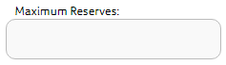 | What is the maximum amount of reserves permitted to be entered into the competition? If the competition you are entering is an individual competition, leave this box blank.
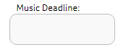 | It is not mandatory that you have a music deadline. If you do have a dead line and it was entered on the event settings. This music deadline will override the original one.

Competition Setup

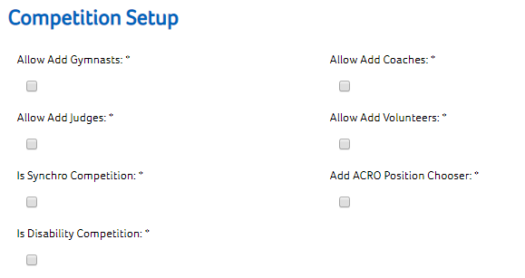

Ticking the boxes will allow a club to enter different entrant types into the competition.

You are only required to tick the boxes of the competition role you would like to enter.

If you don’t tick a box, that individual competition role will be unable to enter by the club.

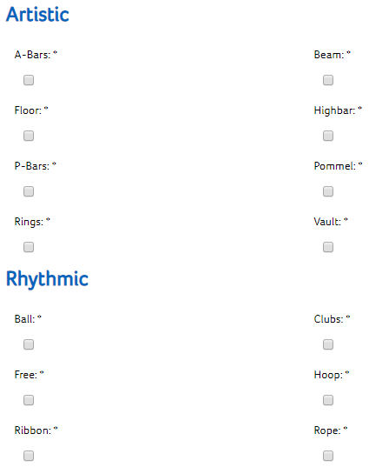
Ticking the boxes for different apparatus will allow a club to choose what apparatus their gymnasts will be competing on.

If you are holding an all-around competition and are expecting gymnasts to compete on each than these boxes can be un-ticked.

Competition Official Levels

When Competition Official Levels are set, this will prevent clubs entering your event without the correct level of coaches or judges. Please be aware that the same judge or coach can be entered throughout the club’s event entry.
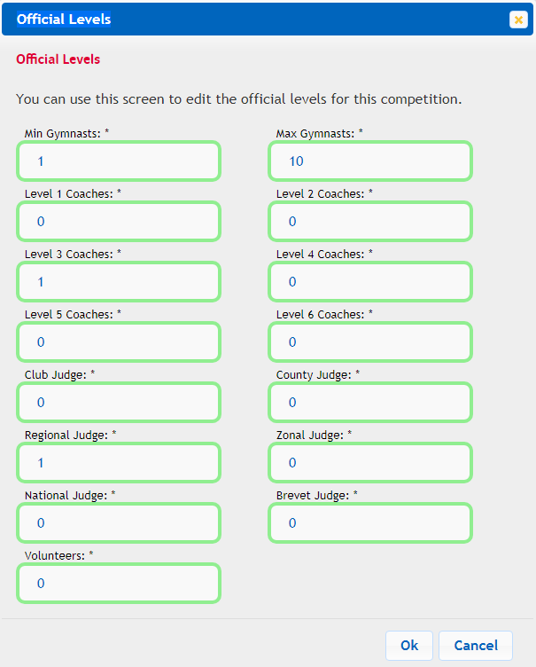
Once you have entered your first set of boundaries, you will need to repeat the process from ‘New Boundary’ if you require extra.

As the region is organising the competition, it is down to you what boundaries you put in place. For example, it may be that for the first 1-10 gymnasts, they are required to bring 1 judge and 1 coach. It may be that, for the next 11-20 gymnasts entered there are two coaches required and two judges.

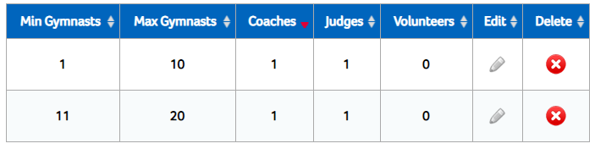
Here is an example of what the boundaries will look like once added.

On the above example, I have set that for the first 1 to 10 gymnasts entered by a club, a level 3 coach and a regional judge. Then for 11 to 20 gymnasts, an additional level 2 and an additional club.

If you select the range to be from 1 to 3 gymnasts (I.E for a partnership in Acro) if a club has more than one partnership to enter, they will be unable to. You will need to increase the range.

Music Requirements

The next page you will be taken to is the ‘Competition Music Requirements’. If you are holding a competition that does not require music, you are able to leave this page by clicking on ‘Save & Back to Competitions’. To add a requirement, you will need to click ‘New Requirement’.

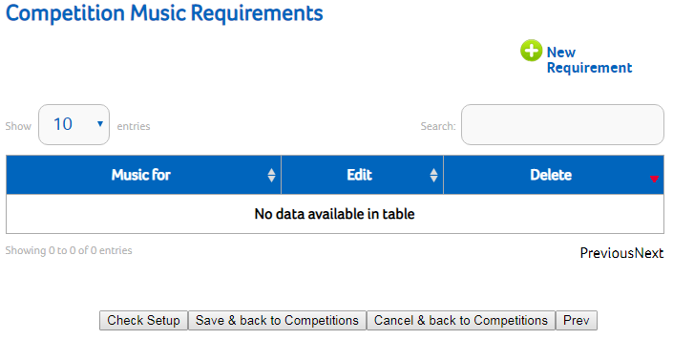

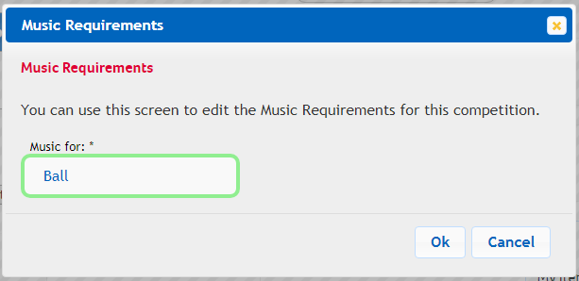
This is the image of the box that will appear when you click on New Requirements.

You will need to add a new requirement for all routines that require music.

I.E:
- Rhythmic – Ball, Hoop, Clubs, Ribbon, Free
- Women’s – Floor
- Acro – Balance, Dynamic, Combined
- TeamGym – Trampette, Tumble, Floor
- Aerobic

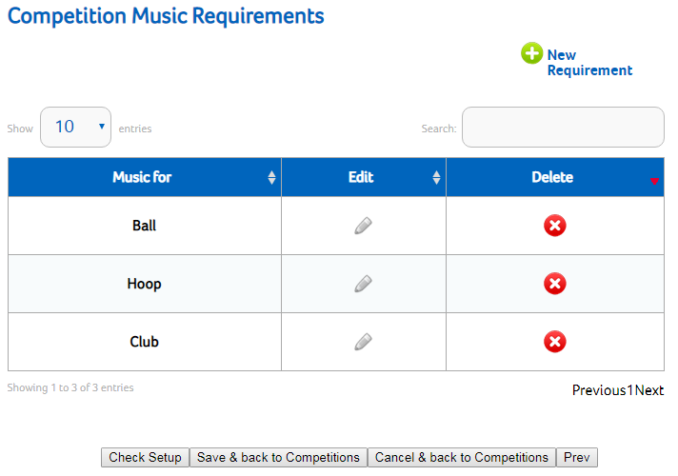
If you enter the incorrect music type, you can edit or delete.

Once all the Music Requirements have been added (If needed), you then need to click ‘Save and back to Competitions’.

Membership Requirements

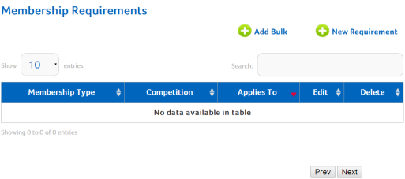
The Next page you will be taken to is ‘Membership requirements’. The membership requirements are for the overall event. This page allows you to ‘Add bulk’ or one ‘New Requirement’ at a time. Select your option on how you want to enter.
Here is how you can change the amount of entries you can see on the page.

If you choose the ‘Add bulk’ it means that you can add more than one type of membership on at a time.

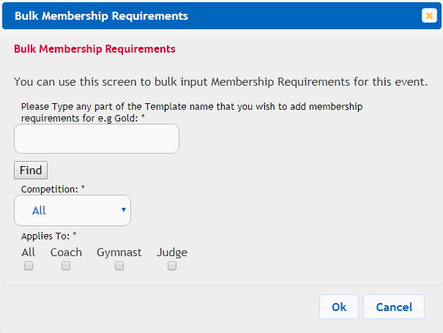
If you choose to add in bulk, you can type what level of membership you are going to enter (Bronze, Silver, or Gold).

You will then need to click find.

When you click find, it will pull up all the templates that sit within our system. You will need to select ONLY the current templates, you can find a list of these on page 16.

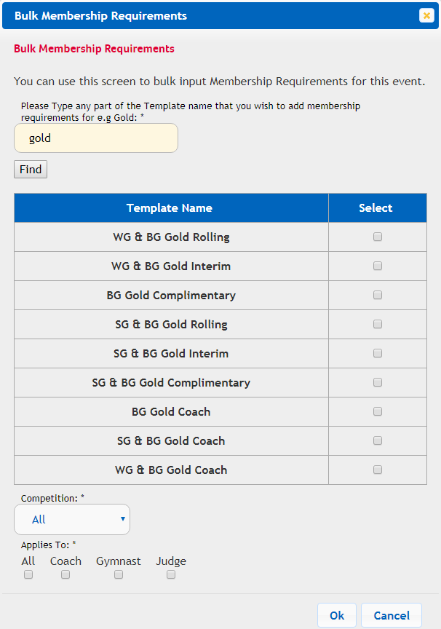
You will need to click in the ‘Select’ box for the current templates.

If these membership types apply to all competition types, you can leave the ‘Competition’ type as ‘All’.

You will also need to select who the membership type applies to. Again, if the template applies to everyone, you can select ‘All’.
- If for example you are using Silver for gymnasts, you can narrow the application down to Gymnasts only.
- This is the same for Judges too if they are able to hold a Bronze Membership.

If you have missed a membership type or would like to add a miscellaneous template, you can do so by selecting ‘New Requirement’.

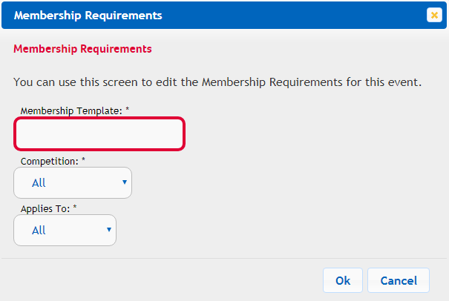

Once you start typing in the level of membership, a drop-down box will show up; you will need to select the correct membership template from the list and who it applies to.

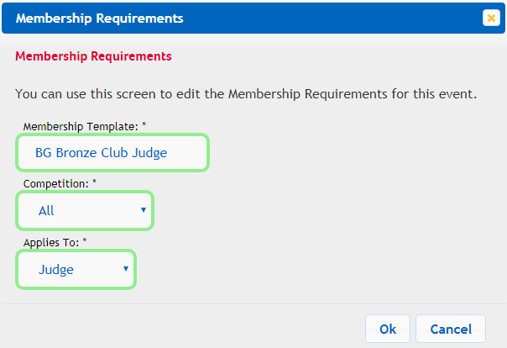

Below is how it will look after this.

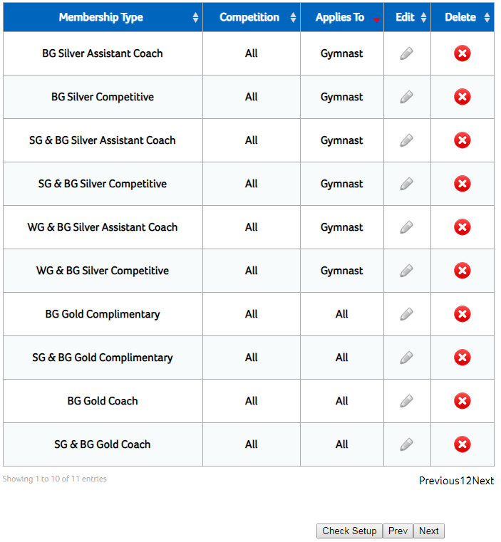

 | Bronze | Silver | Gold
 | BG Bronze Club Administrator  BG Bronze Club Gymnast  BG Bronze Club Judge  BG Bronze Welfare Officer  WG & BG Bronze Club Administrator  WG & BG Bronze Club Gymnast  WG & BG Bronze Club Judge  WG & BG Bronze Welfare Officer  WG Bronze Competitive  SG & BG Bronze Club Helper  SG & BG Bronze Club Gymnast  SG & BG Bronze Club Judge  SG & BG Bronze Safeguarding Officer | BG Silver Assistant Coach  BG Silver Competitive  BG Silver Course Enrolee  BG Silver Activity Instructor  WG & BG Silver Assistant Coach  WG & BG Silver Competitive  WG & BG Silver Course Enrolee  WG & BG Silver Activity Instructor  SG & BG Silver Assistant Coach  SG & BG Silver Competitive  SG & BG Silver Course Enrolee  SG & BG Silver Activity Instructor | BG Gold Coach  BG Gold Complimentary  BG National/Brevet Judge  WG & BG Gold Coach  WG & BG National/Brevet Judge  SG & BG Gold Coach  SG & BG National/Brevet Judge
 |  |  | Miscellaneous
BG Staff
BG Life Member
BG Honorary Life Member
BG Honorary Life Vice President
BG Complimentary
WG & BG Staff
WG Honorary Life Member
SG & BG Honorary Life Member
SG & BG Life Member

Please remember that some gymnasts/judges do cross over in their role within gymnastics, so it may be that you need to link other membership templates to different roles. For example, gold membership for gymnasts and judges as they will need either silver or bronze as a minimum.
Coach & Judge Qualifications

When you click ‘Next’, the page you will be taken to is the ‘Coach & Judge Qualifications’, this will enable you to add in the qualifications that are required for all Judges and Coaches that clubs are entering in to the competition. Like the Membership Requirements page, you can add qualifications by clicking ‘New Requirement’ so it is done individually or by clicking ‘Add Bulk’.

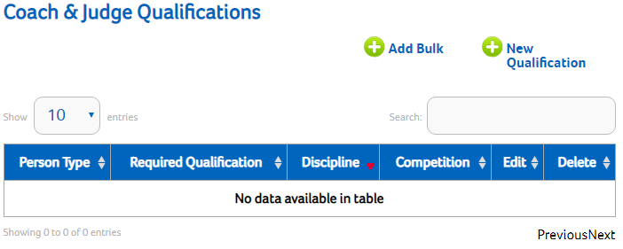

If you add the qualifications on by ‘Bulk’, this means that the level that you enter, all qualifications equivalent and above in that discipline will be pulled through and added on to the event. Below is how to add by ‘Bulk’.
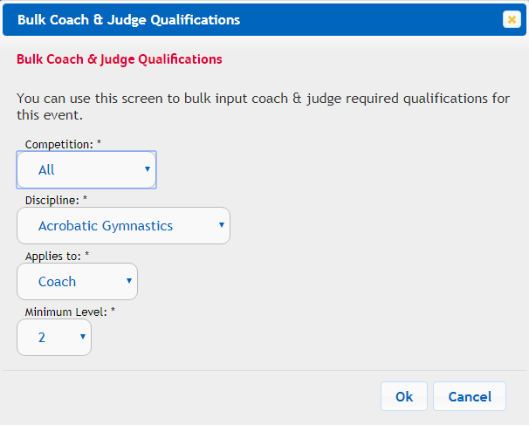
I
You can select what competition the qualification is relevant too. It might be that higher level qualifications are needed for more advanced competitions.

You will need to select the discipline from the drop-down box.

Select who it applies to.

And finally, minimum level required.

If you select Judge, the ‘Minimum Level’ of qualification will change to the relevant names and so does the judging cycle.

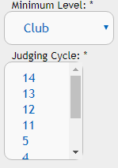
The current cycle that we are on is 14 and will be valid until 2021.
TeamGym is currently on Cycle 5.

When entering qualifications separately, you will have the option to type what qualification you are looking for and the system will pull up all the qualifications that include what you have typed into the box.

Again, you will need to select, what competition, discipline and who it applies to. Below is an example of what it will look like. Unfortunately, we are unable to bulk remove qualifications and it would be a case of removing individually.

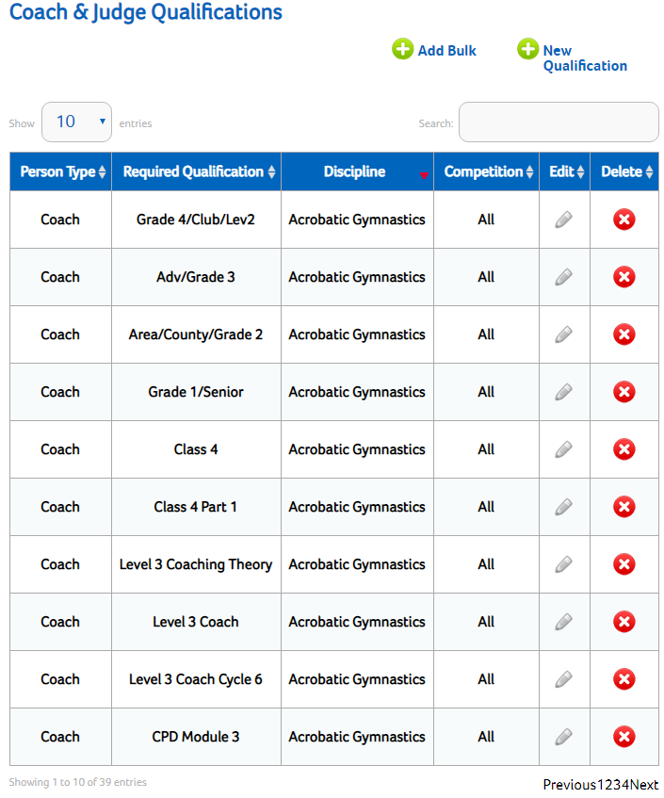

Documents

The last page of the event set up that you will need to go through is the Documents page. This is where you can upload any documents relevant to the event that you are happy for anyone to see as it will sit on the British Gymnastics website and accessible for anyone to download.

To start a document upload, click on ‘New Document’.

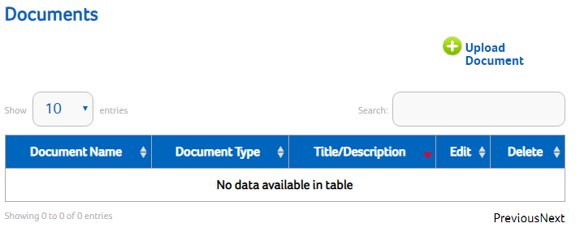
You will need to give the Document Title and select what type of document it is. If it is pre-event information you will need to select ‘Event Web Document’ and if it is results you can select ‘Event Results’.

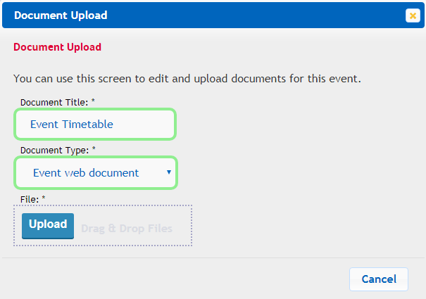

You will then need to click on upload and and select the file you wish to add.

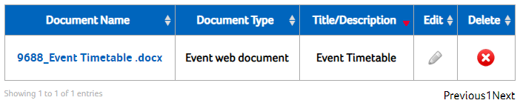

Check Setup

When you have finished here (Don’t forget you don’t have to add documents if you don’t wish too, or you can add them on a later date’. You can then click on ‘Check Setup’.

This will tell you if there are any errors in the set up that may prevent clubs from entering into your event.

Copying an Event from Template

To copy and event from a template you will need to start by clicking on ‘New Event From Template’.
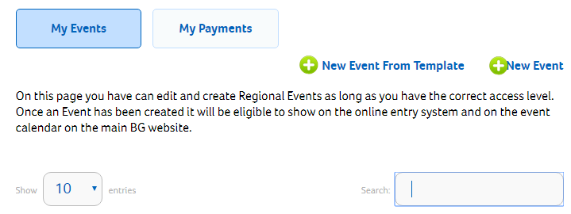

The first box that comes up, you will need to enter the name of the event that you want to copy from, what you would like to call your new event and the year of the new event (this is so the system can calculate the correct date of births).
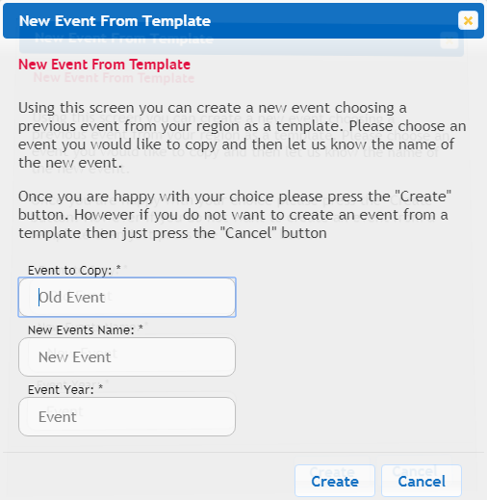
When you start typing the name in the ‘Event to Copy’ box, it will pull up all events within the region that have that name.

Click on the name of the event that you want to copy and then type on the name of the new event in the ‘New Event’s Name’ box. Don’t forget to include the year that the event will be taking place.
Once you have the template and the new name in place, click on ‘Create’.
You will need to find the Event in the search bar and then click on the ‘Edit’ pencil to change the dates etc.

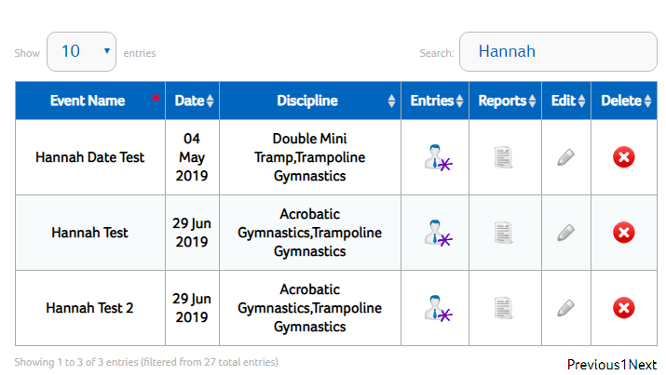

You will be required to work through page by page and change any details that need it. There are a few boxes that will always need to be amended as copying an event will keep all dates remaining the same apart from adding on one year to minimum and maximum birth year.

Please note that the individual competition dates will remain the same as the event they were copied from unless manually changed in each competition set up.

Entries and Overrides

This section is all about the event entries and overrides.

When in ‘My Regional Events’, you will see the list of all events that have been created in your region.

To see who has made an entry (Or make amendments to an entry), you will need to find your event and then click on the entries tab.

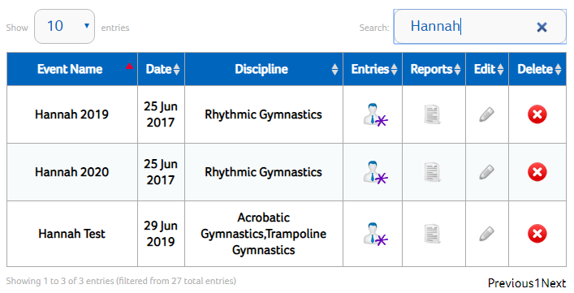
When you click on the Entries button, you will be shown a list of all clubs that have made an entry, the date it was created, the status and an option for further information.

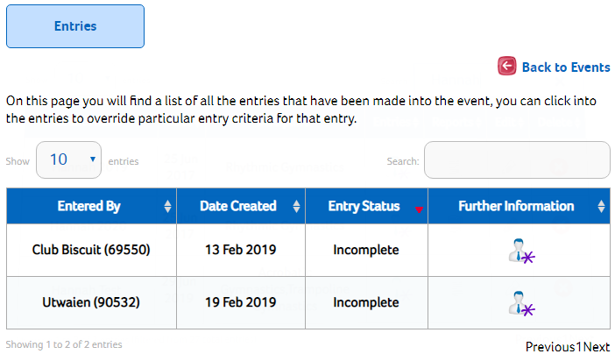
If you click on the further information, you will then be able to see a break down of who the club have entered in to what roles, create extra entries and override certain requirements. Below is an example of how the page will look for a club’s entry.

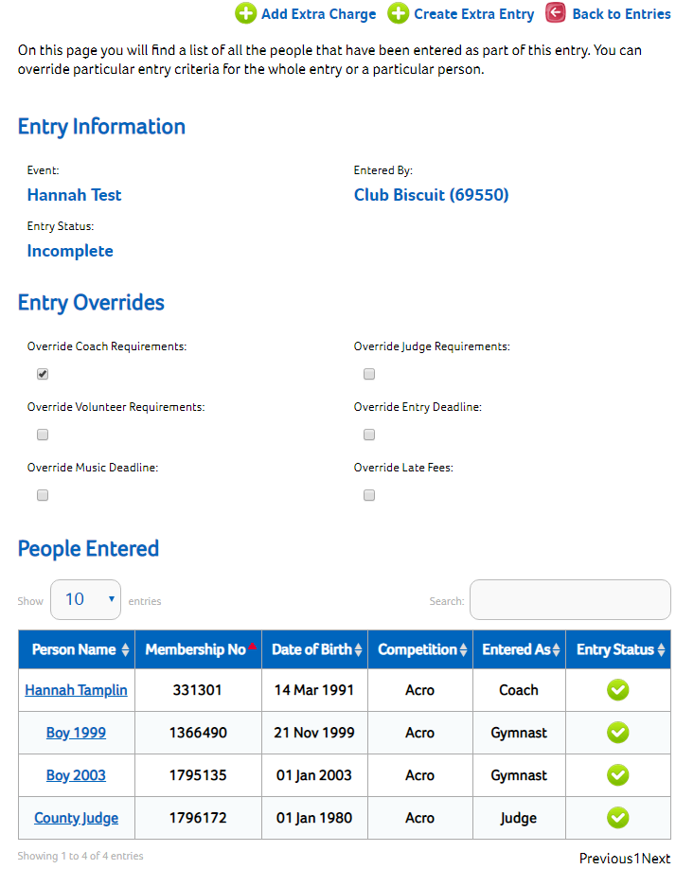

Override Options
The overrides that are shown above will apply to the whole club that are making the entry.
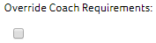 | Override Coach requirements. If, as the competition organiser, you are happy for an entry not to meet up to the coaching requirements. Then selecting this will allow the club to make an entry.
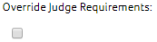 | Override Judge requirements. If, as the competition organiser, you are happy for an entry not to meet up to the judging requirements. Then selecting this will allow the club to make an entry.
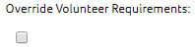 | Override Volunteer requirements. If, as the competition organiser, you are happy for an entry not to meet up to the volunteer requirements. Selecting this will allow the club to make an entry.
 | Override Entry Deadline. If, as a competition organiser, you are happy for a club to make a late entry, then selecting this will allow that one club to enter passed the deadline rather than re-opening up the whole competition. The late fee set in the Event Settings will be charged at this point.
 | If you have agreed a late entry without the fee being paid, selecting this option will allow for a late entry and the fee set, not to be charged.
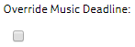 | If you are allowing a club to enter their music that is required for the competition later than the deadline date, then selecting this will allow the club to continue with their entry.

The overrides that are shown above will apply to the whole club that are making the entry. However, if you click on an individual name it will pull up the box below and the override will be specific to that individual person.

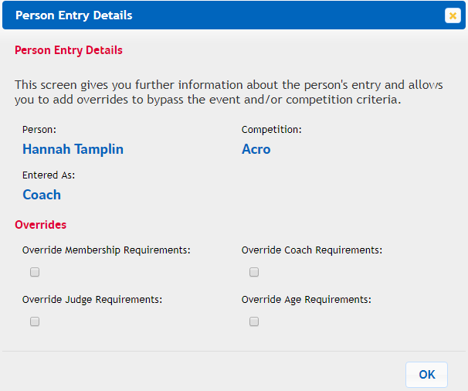

Please remember that with any override, I am not able to do this without written permission from yourself as the organiser.
Adding an Extra Charge

To add an extra charge to the club’s entry, whether this be a judge levy for not providing a judge if you have overridden the requirements or an additional late entry fee, all will you have to do is click on ‘Add Extra Charge’

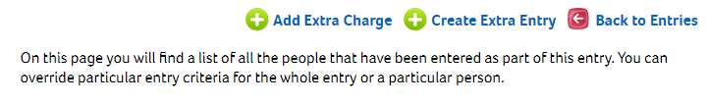

Once you click on the ‘Add Extra Charge’, the below box will appear where you can use the drop-down box to select what type of fee you are adding. Please ensure you choose the correct type as this will show on the club’s entry fees.

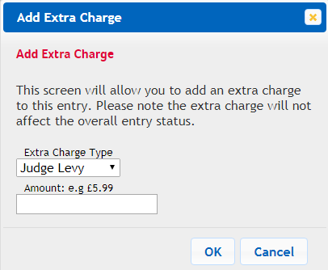

You will then need to enter the amount you wish to charge (you won’t need to enter the £ sign) and then click on ‘OK’.

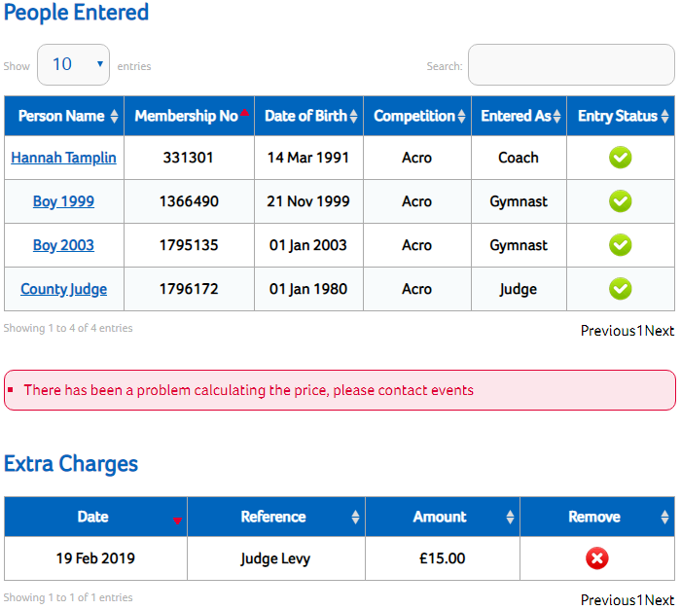

The fee will then sit in the club’s basket. You can remove this fee at any time if it has been added in error or if you need to change the amount for any reason just by clicking the delete button as show to the left.

This is still within the club’s individual entry information.

Creating an Extra Entry

With Regional event entries, unfortunately a club is unable to unsubmit their entry like they can with National events. If a club need to add a gymnast to their entry, you will have to start the next entry for them by clicking on ‘Create Extra Entry’. They will not be able to start a new entry on their own as the system will recognise that the entry to the event has already been made.

To start a new entry for a club, click on the Create Extra Entry button when you are already in the clubs first entry.

The box below will pop up when you click on Create Extra Entry and, if you are 100% sure that you want to create the entry, click on OK.

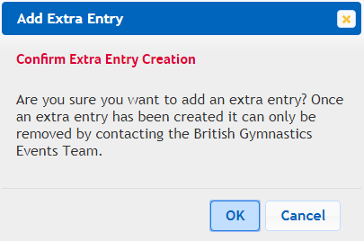

Once you have clicked ok, a message will appear at the top of the screen in a blue box to say, ‘Extra Entry Added, Go back to the Entries Screen to see it’.

Reports

This section is all about the different reports that you can pull which will include all information required for your event. There are 3 different reports that can be pulled.

To pull the report, all you will need to do is click on the pencil button under ‘CSV’. All reports will open in Excel.

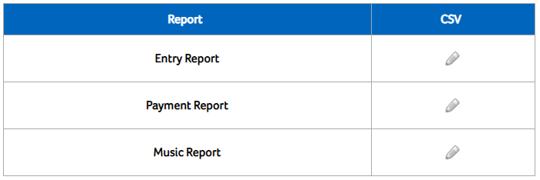

You can of course (as it is a spreadsheet) remove columns that won’t be relevant to you.

Entry Report:
What information will it include? Below is a list of all columns that come through when you select entry report.
Event Name | Event ID | Entry ID
Entry Created | Club Name | Club Number
Club Region | Regional Enterer | Regional Enterer Membership Number
Regional Entry Region | Entry Status | Entered By
Entered By Email | Competition Name | Entry Type
Highest Coaching Award | First Name | Last Name
Gender | DOB | Membership No
Membership Template | DBS Status | DBS Expiry
Safeguarding Expiry | Is Reserve | Team ID
Team Name | Partnership ID | Partnership Name
A Bars | Beam | Floor
High Bar | P Bars | Pommel
Rings | Vault | Bars Heightened
Ball | Clubs | Free
Hoop | Ribbon | Rope
GMPD Grade | Downs | Acro Position
Synchro Name | Synchro Membership Number | Bib
Region-Wide Club Representing | Region-Wide Club Representing ID | Region-Wide Club Representing Number
Overall Cost | Partnership Names | Membership Status

Payment Report:
What information will it include? Below is a list of all columns that come through when you select entry report.

Event Name | Event ID | Club Name
Club Number | Entry Status | Overall Cost
Charge ID | Charge Name | Amount Due
Charge Status | Charge Created | Cheque Reference
Cheque Date | Payment ID | Payment Name
Payment Received | Money Sent From BG | Batch Reference
Entry Paid to Region Directly

Music Report:
What information will it include? Below is a list of all columns that come through when you select entry report.

Event Name | Club Name | Club Number
Competition Name | Competition ID | First Name
Last Name | Gender | DOB
Membership No | Entered By First Name | Entered By Surname
Entered By Mem No | Entered By Email | Music For
Team ID | Music File Short | Music File Long
Music Confirmed | No Music Required | Event ID

Music Download

To download music for your event, this is the link that will be needed.

https://gymnet.british-gymnastics.org/gymnet/musicdownload

Clicking this link will take you to this page below.

You will need to let the sound man know the link and the password other-wise, the music will not be able to be downloaded for the event.

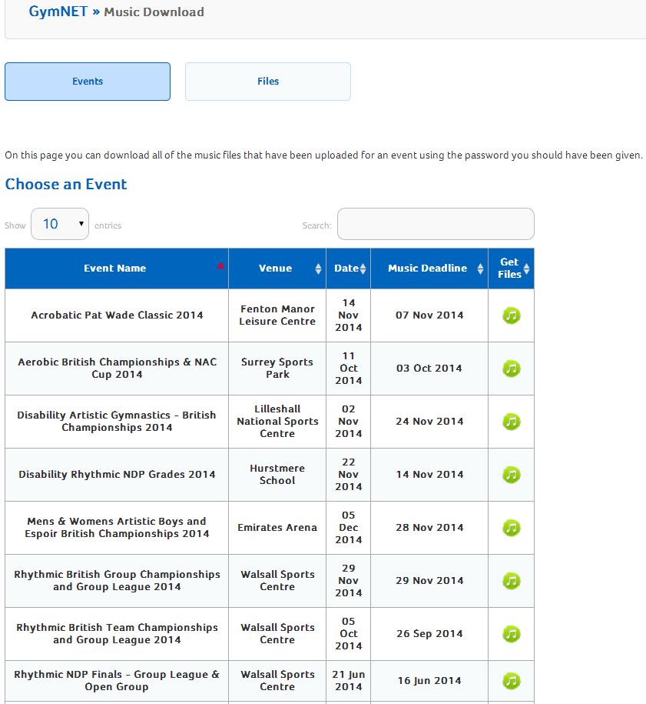

To download the music, firstly, find your event. You will currently be able to see all the events that are on the BG system. However, members are only be able to access the event that they have the password for.

You can search for your event using the search facility or you can change how many events you can see on one page.

When you have found your event, click on ‘Get files’ by clicking the following symbol.

Clicking this link will bring up the following box. This is where the password that was created at the beginning of set-up will now need to be inputted.

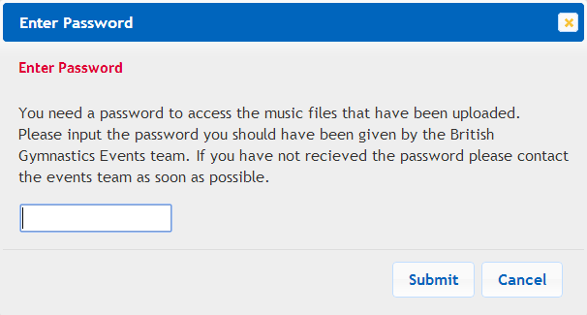
Once the correct password has been entered, this is the page that will be brought up.
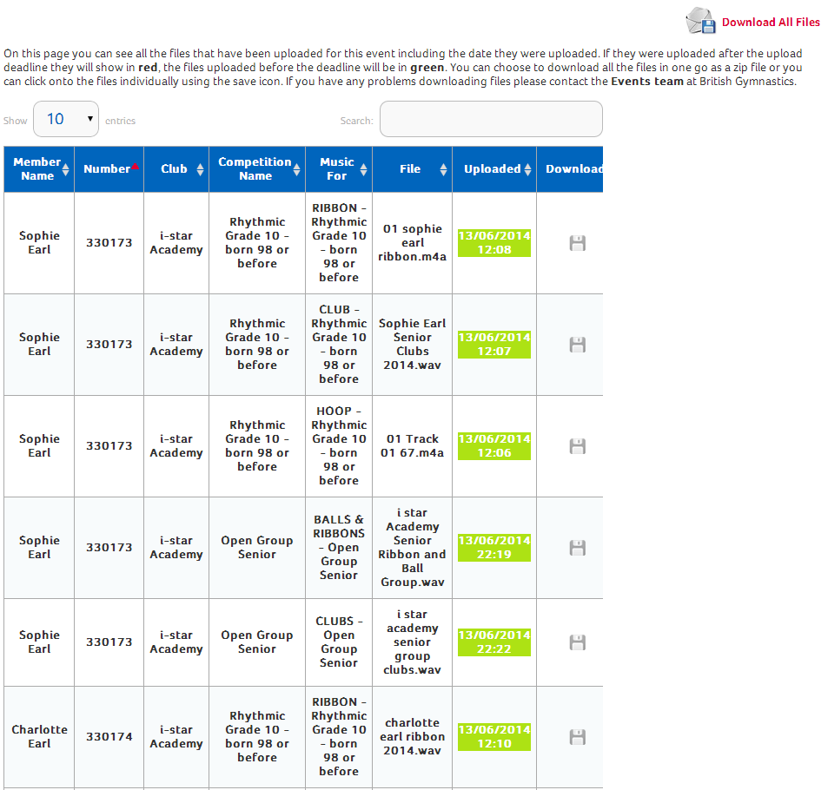

From this page, you are able to download all the music in one go or individually. All music that is uploaded before the closing date shows in green and any after the closing date shows in red.

As always, if you have any queries, please feel free to contact me on the details below.

Hannah.tamplin@british-gymnastics.org
0345 129 7129 EXT. 2569

Notes:

